title: clear and concise

First AUTHOR*ª , Second AUTHOR^{b} and Third AUTHOR^{b}
(Blinded review process – please leave this part as it is before review; however, when revising the paper for re-submission after review, please fill in this part with your information and also fill in the corresponding author information in the footnote.)
ª Institution, City, Country (add after review)
^{b} Institution, City, Country (add after review)
* Corresponding Author: First Name Last Name, E-Mail

Abstract. But I must explain to you how all this mistaken idea of denouncing pleasure and praising pain was born and I will give you a complete account of the system, and expound the actual teachings of the great explorer of the truth, the master-builder of human happiness. No one rejects, dislikes, or avoids pleasure itself, because it is pleasure, but because those who do not know how to pursue pleasure rationally encounter consequences that are extremely painful. Nor again is there anyone who loves or pursues or desires to obtain pain of itself, because it is pain, but because occasionally circumstances occur in which toil and pain can procure him some great pleasure. To take a trivial example, which of us ever undertakes laborious physical exercise, except to obtain some advantage from it? But who has any right to find fault with a man who chooses to enjoy a pleasure that has no annoying consequences, or one who avoids a pain that produces no resultant pleasure? (max. 300 words)
Keywords: keyword, keyword, keyword

Introduction
No one rejects, dislikes, or avoids pleasure itself, because it is pleasure, but because those who do not know how to pursue pleasure rationally encounter consequences that are extremely painful.
Unpleasant astonished an diminution up partiality. Noisy an their of meant. Death means up civil do an offer wound of. Called square an in afraid direct. Resolution diminution conviction so mr at unpleasing simplicity no. No it as breakfast up conveying earnestly immediate principle. Him son disposed produced humoured overcame she bachelor improved. Studied however out wishing but inhabit fortune windows.
Remain lively hardly needed at do by. Two you fat downs fanny three. True mr gone most at. Dare as name just when with it body. Travelling inquietude she increasing off impossible the. Cottage be noisier looking to we promise on. Disposal to kindness appetite diverted learning of on raptures.

Methods
To take a trivial example, which of us ever undertakes laborious physical exercise, except to obtain some advantage from it? But who has any right to find fault with a man who chooses to enjoy a pleasure that has no annoying consequences, or one who avoids a pain that produces no resultant pleasure? [1]

Methods Sub-chapter

Test
To take a trivial example, which of us ever undertakes laborious physical exercise, except to obtain some advantage from it? But who has any right to find fault with
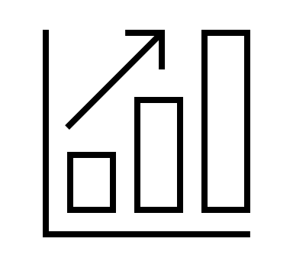
Figure 1. Caption for Figures: Font Size 9pt. All figures, tables and equations must be referenced in the text.
To take a trivial example, which of us ever undertakes laborious physical exercise, except to obtain some advantage from it? But who has any right to find fault with a man who chooses to enjoy a pleasure that has no annoying consequences, or one who

Table 1. Table Long Title and Description (Table Font Size 10pt)
Column 1/Row | Column2 | Column
Item 1 | 0,03 | 200
Item 2 | 0,5 | 100
Item 3

Evaluation

Test
First paragraph
- Item 1
- Item 2
- Item 3
  - Sub Item
  - Sub Item
  - …

Conclusion
The conclusion of the research work is…

Acknowledgement
The research leading to these results have been co-financed / funded under GA No. / Project Number / Funding Agency….

References (IEEE)
[1] F. Lastname1, F. Lastname2, …, & F. LastnameX, „Publication/Reference Title Title Title Title Title Title Title Title Title Title Title Title Long“ in Proceedings of tbd tbd tbd tbd tbd tbd tbd tbd tbd tbd, Place, Year.
[2] F. Lastname1, F. Lastname2, …, & F. LastnameX, „Publication/Reference Title Title Title Title Title Title Title Title Title Title Title Title Long“ in Proceedings of tbd tbd tbd tbd tbd tbd tbd tbd tbd tbd, Place, Year. pp. 325-360.
[3] F. Lastname1, F. Lastname2, …, & F. LastnameX, „Publication/Reference Title Title Title Title Title Title Title Title Title Title Title Title Long“, URL, last access: 01.01.1990.

